**Power BI Project – Netflix Data Dashboard**

**Objective :** The Netflix Dashboard provides a comprehensive analysis of Netflix’s content catalog. The primary objectives of this dashboard are to visualize the distribution of content types, track the addition of new content over time, explore the distribution of ratings, and highlight the top 5 countries producing Netflix content. These insights will help stakeholders understand Netflix’s content library, track growth trends, and analyze the global distribution and characteristics of the content.

**Dataset Overview and Data Processing :** The dataset contains information about Netflix’s content, including attributes like

* **show_id :** A unique identifier for each show or movie.
* **type :** Indicates whether the entry is movie or TV show.
* **title :** The title of the show or movie.
* **director :** The name of the director of the show or movie. If there is no director the field gives value as Not Given.
* **country :** The country where the show or movie was produced.
* **date_added :** The date when the show or movie was added to Netflix.
* **release_year :** The year the show or movie was originally released.
* **rating :** The rating assigned to the show or movie, indicating its suitability for different audiences.
* **duration :** The length of the movie in minutes or the number of seasons for TV shows.
* **listed_in :** The genres or categories the show or movie is listed under on Netflix.

It provides a detailed view of the movies and TV shows available on the platform. During data processing the data was imported to Power BI, and key transformations were applied to ensure accuracy, such as converting date fields to the correct format.

Additionally, **new columns were created using DAX formulas** to derive insights on the year content was added as well as on the Month content added.

**Insights and Findings :**

Based on the visualizations and analysis performed on the Netflix dataset, several key insights and findings have emerged. It reveals that volume of new content additions has significantly increased over the years, with noticeable peaks during 2018. The United States leads in content volume, but there’s a diverse representation from other countries, reflecting Netflix’s global strategy. Drama, International movies and Documentary are the most prevalent genres, catering to board audience. Additionally, the majority of content is rated for mature audience, though there is also a considerable amount of family-friendly programming available. These insights provide a comprehensive understanding of Netflix’s content strategy and the evolution of it’s library over time. This information can be valuable for strategic decision-making, content planning and understanding viewer preferences.

**Steps to create Dashboard:**

1. Import Data from PostgreSQL Database:

Connect to Server

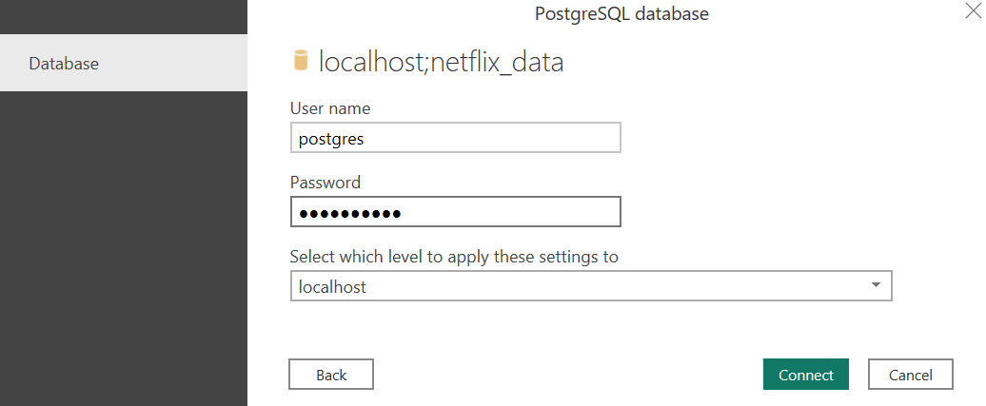

1. **Title:**

Once loaded Select the **Text Box** Visual.

Visual looks like this



1. Select a **Card** Visual and select ‘show_id’ column from netflix1 table and select the value to be shown as count. Visual looks like this.



1. Select a **Card** Visual and select ‘YearAdded’ column from netflix1 table and select the value to be shown as Minimum. Visual looks like this.

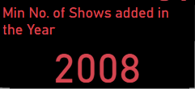

1. Select a **Card** Visual and select ‘YearAdded’ column from netflix1 table and select the value to be shown as Maximum. Visual looks like this.

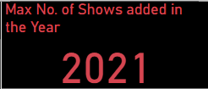

1. **Type** **:**

Select **Donut Chart** Visual and add below columns:

* Type

Visual look like this

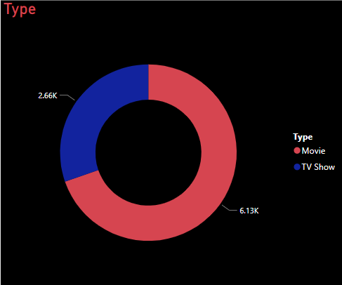

This shows the two categories of content in the dataset which are Movie and Tv show. As we can see the majority of the content is Movie which takes 69.9%.

1. **Number of Type By Country :**

Select **Stacked Bar Chart** Visual and add below column:

* Country
* type

Visual looks like this

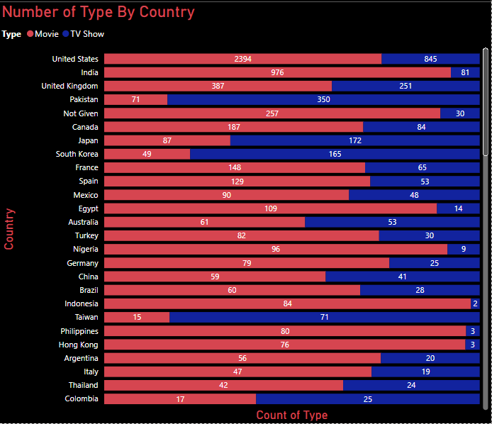

This shows the exact count of Movies and Tv shows per country within the given period of time 2008 - 2021. United states is producing more Movies and TV shows compare to other country.

1. **Number of Shows By Type :**

Select **Clustered Column Chart** Visual and add below columns:

* type and show_id from netflix1 table.

Visual look like this

This shows the Movie and TV show count based on show_id.

1. **Top 10 Directors :**

Select **Stacked Bar Chart** Visual and add below columns:

* director and type from netflix1 table.

Visual look like this

This shows the top 10 directors with most contents on Netflix. We can see that most of these directors contents are movies.

We can also note that the duo of Raul Campos and Jan Suter are fond of working together and have directed 18 movies on Netflix.

Furthermore, Alastair Fothergill is fond of working in TV shows.

1. **Top 5 Countries :**

Select **Clustered Bar Chart** Visual and add below columns:

* country and show_id from netflix1 table.

Visual look like this

This shows the Top 5 countries which produces more number of movies and TV shows.

1. **Number of Shows added per Year :**

Select **Line Chart** Visual and add below columns:

* Release_year and YearAdded from netflix1 table.

This time series chart shows the total number of contents added to Netflix all through the given years (2008 - 2021).It shows that most movies and tv shows on Netflix were added in 2018.

YearAdded is a **new column** added by using **DAX Formula**.

1. **Count of Movies and TV Shows Added Each Month :**

Select **Clustered Column Chart** Visual and add below columns:

* Month, show_id and type

Visual look like this

This chart shows the Movies and TV shows on each Month. It shows that most Movies were added in the Month of July.

The Months in the right hand side was written using **Text Box**.

Month is a **new column** added by using **DAX Formula**.

1. **Distribution of Rating :**

Select **Pie Chart** Visual and add below columns:

* rating

Visual look like this

This chart shows the distribution of ratings on Netflix. We can note that most contents on Netflix are rated TV-MA. TV-MA in the United States by the TV Parental Guidelines signifies content for mature audiences.

1. **Genres :**

Select **Clustered Bar Chart** Visual and add below columns:

* Listed_in, show_id and type

Visual look like this

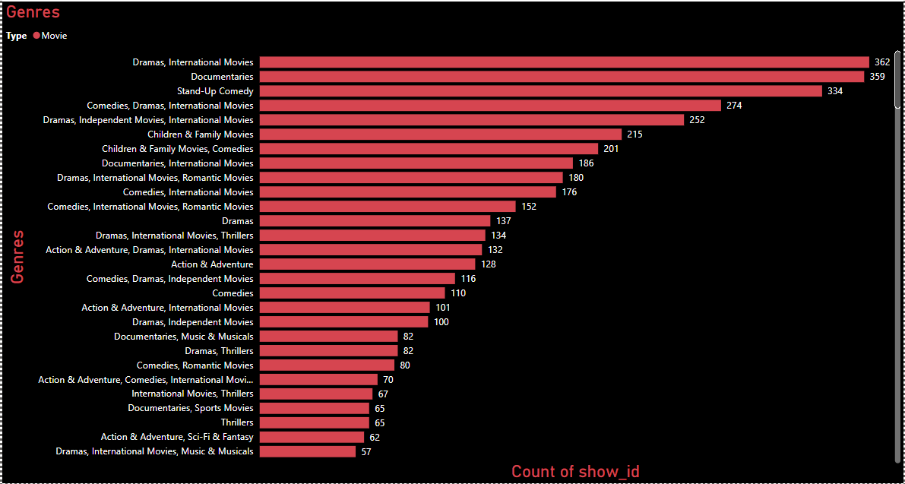

Visual filter is applied to get only movies genres. This chart shows the genres with the highest numbers on Netflix. We can see that Drama & International movies followed by Documentary have the highest number of contents on Netflix within the period.